PROJECTIONEERING
Seeing tomorrow today

May 13, 2015

Pamela G. Bailey
President & CEO
Grocery Manufacturer’s Association
1350 I Street Northwest
Suite #300
Washington, DC 20005

VIA CERTIFIED MAIL

Dear Ms. Bailey:
Please find enclosed an Affidavit of Truth being served directly to you in your capacity as the President of the Grocery Manufacturers Association (GMA). This Affidavit of Truth is served upon you as the President of GMA under the auspices of the Uniform Commercial Code and the laws of the United States of America.
Please note that your counter-affidavit, if any, must bear your personal original signature to be valid. The completion of the attached document is also time sensitive. Your counter-affidavit must be received by Projectioneering LLC within forty-five (45) calendar days from the date of service.
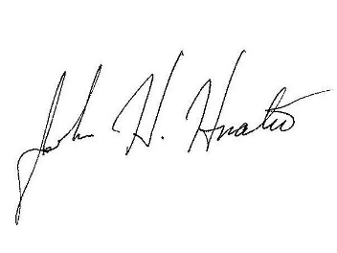
If you have any questions regarding the enclosed Affidavit of Truth please feel free to contact me.
Sincerely yours,

John H. Hnatio, EdD, PhD
President

cc w/attachment:

Dr. Ostroff, FDA
Dr. Wadsworth, BMI
Mr. MacLennan, Cargill
Dr. Piervincenzi, USPC

