PROJECTIONEERING
Seeing tomorrow today

May 26, 2015

Dr. Jeffrey Wadsworth
President & CEO
Battelle Memorial Institute
505 King Avenue, Room A-353
Columbus, OH 43201-2696

VIA CERTIFIED MAIL

Dear Dr. Wadsworth:
Please find enclosed an Affidavit of Truth being served directly to you in your capacity as the President and Chief Executive Officer of Battelle Memorial Institute (BMI). This Affidavit of Truth is served upon you as the President and Chief Operating Officer of BMI under the auspices of the Uniform Commercial Code and the laws of the United States of America.
Please note that your counter-affidavit, if any, must bear your personal original signature to be valid. The completion of the attached document is also time sensitive. Your counter-affidavit must be received by Projectioneering LLC within forty-five (45) calendar days from the date of service.
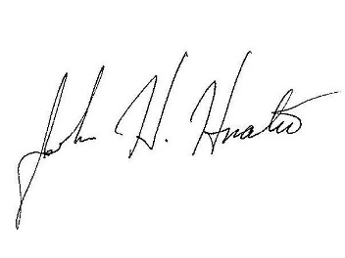
If you have any questions regarding the enclosed Affidavit of Truth please feel free to contact me.
Sincerely yours,

John H. Hnatio, EdD, PhD
President

cc w/attachment:

Dr. Ostroff, FDA
Ms. Pamela Bailey, GMA
Mr. DeWine, AGOH

